Dynamics of cell death due to N and P starvation across intra-clade diversity in Prochlorococcus
Yara Soussan-Farhat, Shira Givati, Osnat Weissberg, Waseem Bashir Valiya Kalladi, Dikla Aharonovich and Daniel Sher
Department of Marine Biology, Leon H. Charney School of Marine Sciences, University of Haifa, Haifa, Israel.

Supplementary text S1: Growth curves of MED4 and MIT9312 in four independent experiments.
Due to the large number of strains and conditions tested, we performed four different experiments, each with different strains. In order to make sure that there is no “batch effect” (i.e. that observed differences in starvation and mortality between strains are not in fact due to experiment-to-experiment variation), we included in each experiment two strains, MED4 and MIT9312, as internal standards. In some experiments a short lag phase was observed, for example under lowN (1:8) and lowP (1:50) in experiment 1 for MED4. This could be due to slightly different timing of transfer from phase 1 (acclimation to low nutrient media) to phase 2 (the actual experiment). However, the death phase, which was the primary focus of this study, exhibited consistent patterns and high reproducibility (Figure 2, Supplementary figure S2).
Supplementary text S2: The environmental measurements tested here was monthly interpolated data from the World Oceanic Atlas (WOA).
Since complete environmental data were not available for all strains from the cruises on which they were isolated, we supplemented our dataset with information from WOA. To ensure consistency, we first compared the available strain-specific data with the corresponding WOA data (Supplementary figure 5A) and found no significant variability.
The WOA provides data at monthly, seasonal, and annual resolutions. To assess the impact of these different timescales, we conducted comparative analyses. Nitrate and phosphate measurements exhibited some differences (Supplementary figure 5B). But no significant correlations were observed when mean seasonal and annual conditions were used (Supplementary table S4). Based on these findings, we selected monthly data for our analysis, as it provides a representative and reliable resolution for our study.

Supplementary tables:

Supplementary Table S1: Nutrient concentrations and their ratios in the different media.
Media | Ammonium-N (µM) | Phosphate- P (µM) | N/P ratio
Pro99 | 800 | 50 | 16
lowN (1:8) | 100 | 50 | 2
lowP (1:8) | 800 | 6.25 | 128
lowP (1:50) | 800 | 1 | 800

Supplementary Table S2: ordinary least squares (OLS) statistical test with multi test correction using the Benjamini–Hochberg method results of death features across the tested strains.

MIT1327 | a | b | c | d | NS | NS | NS | NS | a | b | b | b
MIT9313 | a | b | b | c | a | b | b | b | a | b | b | b
PAC1 | a | b | a | c | a | b | b | b | a | a | b | b
NATL2A | a | b | c | d | a | b | a | b | a | b | c | c
NATL1A | a | b | ab | c | NS | NS | NS | NS | a | b | c | d
MIT1314 | a | b | c | d | a | b | b | b | a | b | c | c
MIT9312 | a | b | b | c | a | b | b | b | a | b | c | c
AS9601 | a | b | a | c | a | b | c | bc | a | b | a | c
SB | a | b | c | d | a | ab | b | b | a | b | c | d
MIT9301 | a | b | c | d | a | b | b | b | a | b | b | b
MIT0604 | a | b | a | c | NS | NS | NS | NS | a | b | c | b
MIT9215 | a | b | b | c | a | b | ab | b | a | b | c | c
MIT9202 | a | b | a | c | a | b | ac | bc | a | b | c | d
MIT9515 | a | b | c | d | a | b | b | b | a | b | c | c
MED4 | a | b | a | c | a | b | a | c | a | b | c | c
Feature | Max_{FL} |  |  |  | Peak count |  |  |  | D-value
Strain/Medium | Pro99 | lowN | lowP (1:8) | lowP (1:50) | Pro99 | lowN | lowP (1:8) | lowP (1:50) | Pro99 | lowN | lowP (1:8) | lowP (1:50)

Supplementary table S3: grouping based on sensitivity of a strain according to each one of the features.
Strain/feature | Max_{FL} | Peak count | D-value
MED4 | N | N | N
MIT9515 | N | N/P | N
MIT9202 | N | N | N
MIT9215 | N/P | N | N
MIT0604 | N | N/S | N
MIT9301 | N/P | N/P | N/P
SB | P | P | P
AS9601 | N | N | N
MIT9312 | N/P | N/P | N
MIT1314 | P | N/P | N
NATL1A | N/P | N/S | N
NATL2A | N | N | P
PAC1 | N | N/P | P
MIT9313 | N/P | N/P | N/P
MIT1327 | N | N/S | N/P

Supplementary table S4: Statistical tests showing the correlation between the N vs. Other sensitive groups and the measurements included.
 | p-value results when testing N vs. Other sensitive according to
Measurement | Max_{FL} | Peak count | D-value
Temperature | 0.49 | 0.43 | 0.68
Nitrate | 0.56 | 0.72 | 0.32
Phosphate | 0.68 | 0.07 | 0.24
GC% | 0.73 | 0.38 | 0.01
N acquisition genes | 1.00 | 0.72 | 0.08
P acquisition genes | 0.20 | 0.35 | 0.31

Supplementary table S5: Statistical tests showing the correlation between the D-values and the interpolated environmental measurements from the World Oceanic Atlas (WOA).
 | p-value results when testing D-value against environmental measurements
Measurement | Monthly | Seasonal | Annual
Temperature | 0.68 | 0.52 | 0.60
Nitrate | 0.32 | 0.28 | 0.32
Phosphate | 0.24 | 0.26 | 0.39

Supplementary figures:
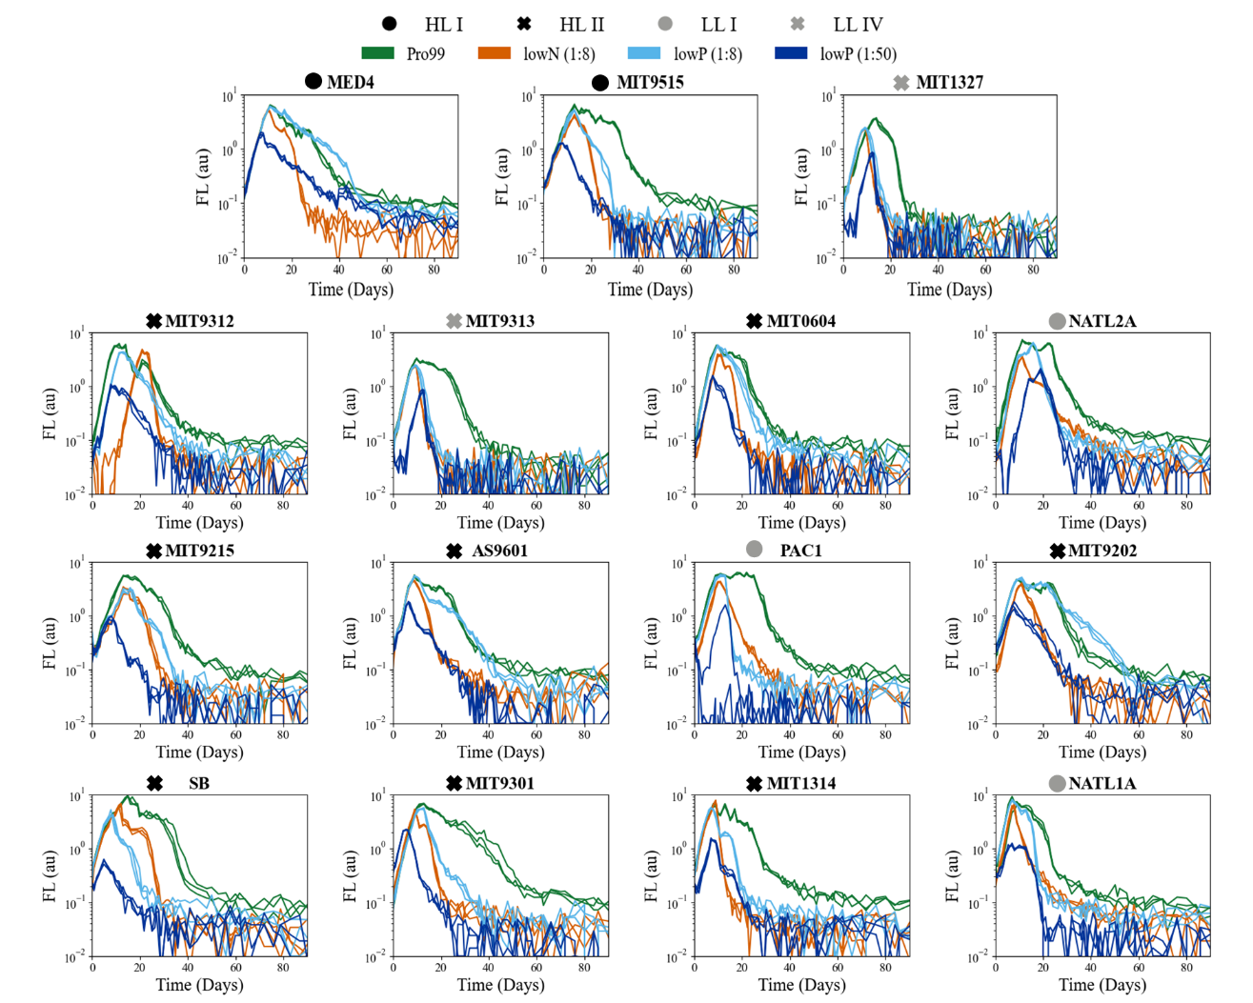
Supplementary figure S1: Growth curves of 12 strains, the x-axis represents time in days and the y-axis is FL, a proxy for cell growth, on a logarithmic scale. Colors represent the nutrient media cultures grow under, while shapes describe the clades. The curves for MED4 and MIT9312 are from a representative individual experiment.

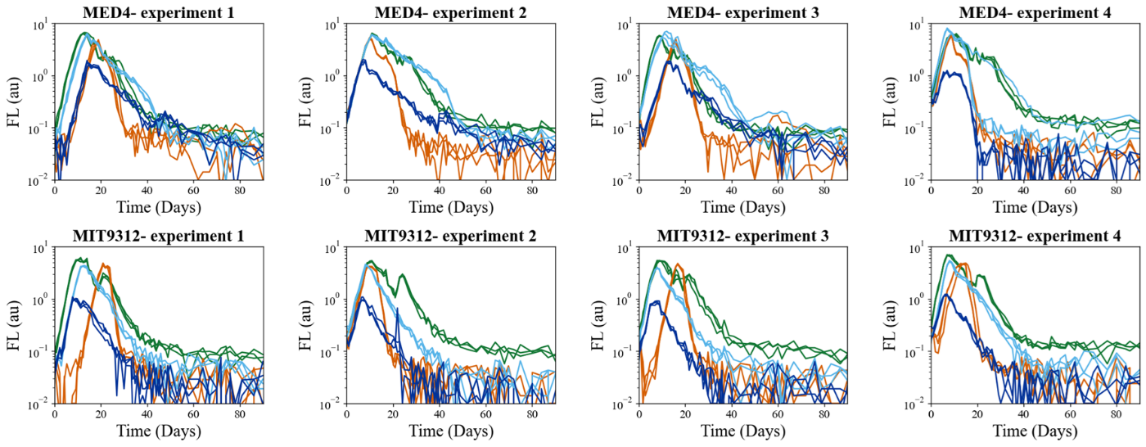
Supplementary figure S2: Growth curves of MED4 and MIT9312 in four independent experiments.

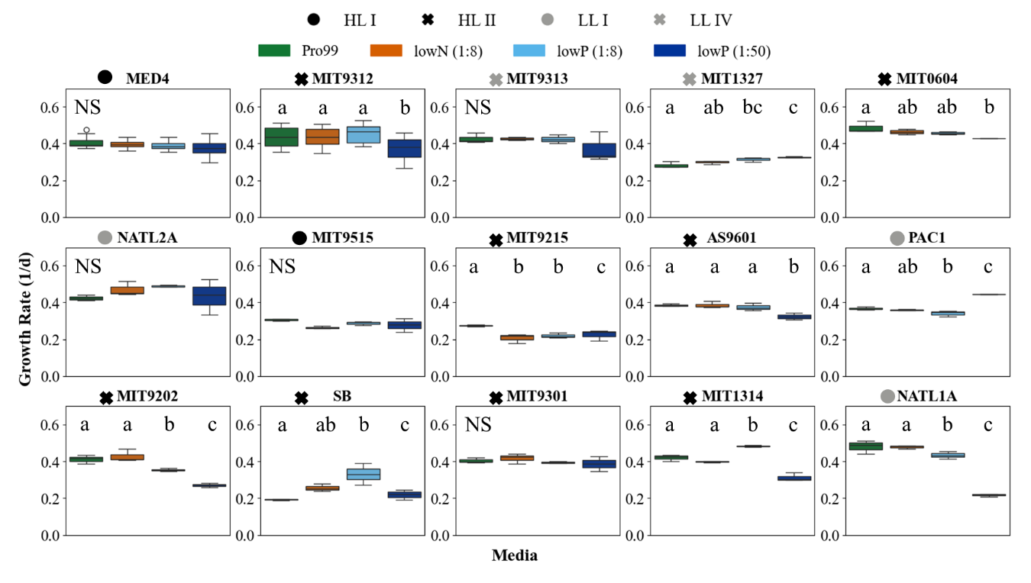
Supplementary figure S3: Growth rates result across media in each strain. Colors represent the different media. Statistical test results are overlayed. Not significant (N/S) marks strains with no differences across media.

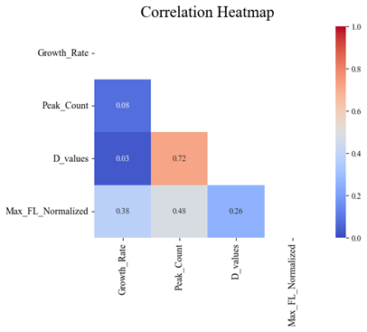
Supplementary figure S4: Pearson correlations between the distinct death features.

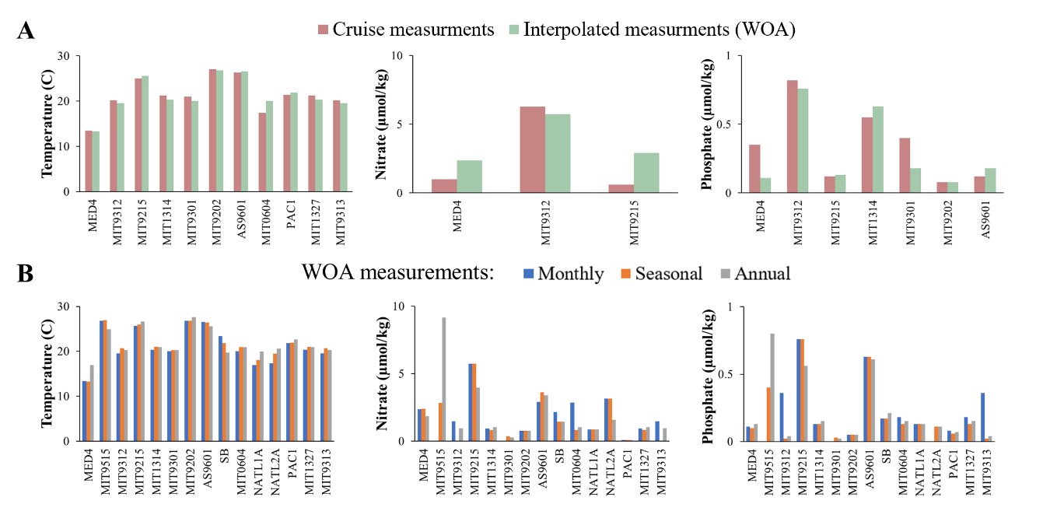
Supplementary figure S4: Compresence between data from cruises and interpolated data from the World Oceanic Atlas (WOA).
A. cruise data vs. interpolated data. B. comparisons between monthly, seasonal and annual data from the WOA.

